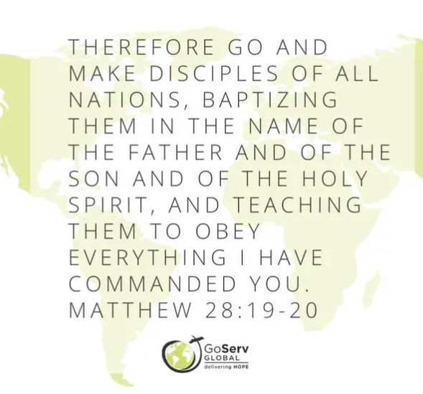
Samuel Lutheran Church
Congregational
Challenge

We are so blessed!
It is hard to fathom people who don’t have
something that we take for granted...water.
In scripture, we often find references to the "living water" and God regularly invites all who are thirsty to come to the well that doesn't run dry. While spiritual water is extremely important, something we also need is clean drinking water!
One of GoServ Global’s newest missions is digging wells that will provide fresh, safe water. Paul and Joanie vanGorkom visited with Samuel about a country where people have to walk many miles to carry water back to their homes. The water they drink, cook, and bathe in is the same water where their buffalo live and bathe. $1,500 will purchase a new clean well that will provide fresh, safe water for 100 families. Not only will this well provide safe water to drink, cook, and bathe in, it will help to eliminate sickness and disease for many people.

Congregational Challenge
Samuel Lutheran Church Council believes this is an excellent opportunity for global mission giving. We would like to encourage the members of our congregation to donate to this extreme need in India. Samuel will match all donations.
The challenge is big…BIG…Let’s shoot for 10 WELLS!!!
Prayerfully consider giving to this vital, life-sustaining project.
We ask that you keep the leaders and volunteers of GoServ Global in your prayers as they continue to embark on new ways to help people in need as they also spread the Good News of the Lord.

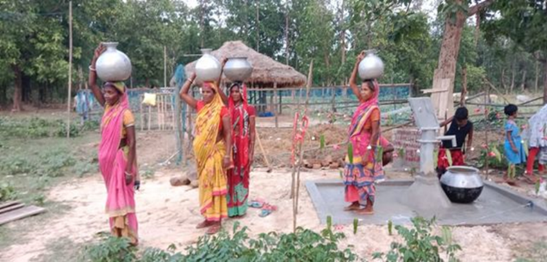
Please use the enclosed envelope to mail your donation to Samuel Lutheran Church.
In the memo line, please indicate that it is for GoServ Global Wells.
You can also put your donations in the offering plate at Church.
Donations can be given through the month of August.

Empowering those we serve
and serve alongside to be
World Changers transformed
through Jesus.

